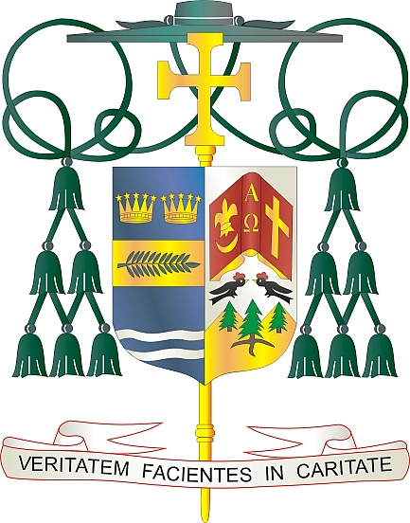

Office of  
THE BISHOP

9995 North Military Trail • P.O. Box 109650

Palm Beach Gardens, Florida 33410-9650

(561) 775-9595 Fax (561) 775-7035

## Diocese of Palm Beach

January 6, 2024

Dear Sisters and Brothers in Christ:

Next weekend, January 13/14, the faithful of the Diocese of Palm Beach are invited to support our local Catholic schools. The 20 schools in our Diocese include three high schools, three preschools, two private schools and 12 elementary schools. Thanks to the dedication of more than 550 teachers, administrators, guidance counselors and other school staff, our Diocese is educating more than 7,000 students this year, representing an enrollment increase of more than 6% over last year.

The theme adopted by the Office of Catholic Schools for 2023-2024 is *Faith Illuminating Knowledge.* The mission of a Catholic school is to foster nurturing communities, teach respect for self and others, encourage students to live their faith, and provide individualized attention to build a strong basis for life. The central goal of Catholic schools is to educate future pillars of the faith grounded in Christ, the light of the world and the cornerstone of faith.

I invite our parishioners to give the gift of faith to a student wishing to attend a Catholic school in our Diocese. Your financial contribution provides funding for programs and resources at each school. Thank you so much for your faithful support, prayers, and gifts to assist the students and families in our Catholic schools.

With gratitude for your continued generosity and every prayerful wish, I am

Sincerely yours in Christ,

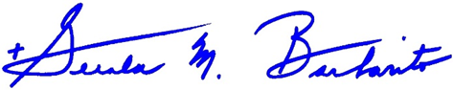

Most Reverend Gerald M. Barbarito  
 Bishop of Palm Beach

**NOTE TO PASTORS: IT IS REQUIRED THAT YOU PUBLISH THIS LETTER IN THE PARISH BULLETIN AS A HALF-PAGE OR FULL-PAGE LETTER THE WEEKEND OF JANUARY 6/7, 2024. THE COLLECTION WILL TAKE PLACE JANUARY 13/14, 2024. YOU ARE WELCOME TO READ THE LETTER TO PARISHIONERS, POST THE LETTER ON SOCIAL MEDIA, AND ON YOUR WEBSITE, IN ADDITION TO HAVING IT PRINTED IN THE BULLETIN.**