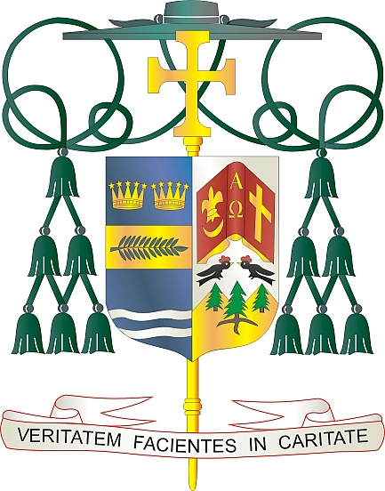

Office of  
THE BISHOP

9995 North Military Trail • P.O. Box 109650

Palm Beach Gardens, Florida 33410-9650

(561) 775-9595 Fax (561) 775-7035

## Diocese of Palm Beach

May 10, 2024

Dear Sisters and Brothers in Christ:

Next weekend, there will be a special collection for the Catholic Communication Campaign and Catholic University of America. These worthy causes ensure that the Gospel message is spread throughout our Diocese of Palm Beach, nation and world.

The Catholic communication portion of the collection supports national communication efforts and our interactive diocesan projects, such as the weekly Televised Catholic Mass, *Florida Catholic* e-edition, our active social media presence and website ([www.DiocesePB.org](http://www.DiocesePB.org)). These modern media tools help the Church inform, instruct and inspire.

As Pope Francis said in his 58th World Communications Day message for 2024: “All of us are called to grow together, in humanity and as humanity. We are challenged to make a qualitative leap in order to become a complex, multiethnic, pluralistic, multireligious and multicultural society. We are called to reflect carefully on the theoretical development and the practical use of these new instruments of communication and knowledge.” Your donation helps make that possible.

The portion of the special collection for Catholic University of America supports the United States Bishops’ national university in Washington, D.C. It is the only institution of higher learning established by our bishops, with its first founding principle in 1887 that it be “faithfully Catholic.”

With gratitude for your continued generosity and every prayerful wish, I am

Sincerely yours in Christ,

Most Reverend Gerald M. Barbarito  
 Bishop of Palm Beach

**NOTE TO PASTORS: IT IS REQUIRED THAT YOU PUBLISH THIS LETTER IN THE PARISH BULLETIN AS A HALF-PAGE OR FULL-PAGE LETTER THE WEEKEND OF MAY 11/12, 2024. THE COLLECTION WILL TAKE PLACE MAY 18/19, 2024. YOU ARE WELCOME TO READ THE LETTER TO PARISHIONERS, POST THE LETTER ON SOCIAL MEDIA, AND ON YOUR WEBSITE, IN ADDITION TO HAVING IT PRINTED IN THE BULLETIN.**