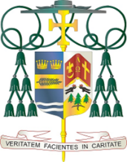

## Diocese of Palm Beach

9995 North Military Trail • P.O. Box 109650

Palm Beach Gardens, Florida 33410-9650

(561) 775-9595 Fax (561) 775-7035

Office of  
THE BISHOP

November 1, 2024

Dear Brothers and Sisters in Christ:

Next weekend, November 9/10, a collection for the Catholic Campaign for Human Development will be taken up in the Diocese of Palm Beach. For more than 50 years, CCHD has helped address the root causes of poverty in the United States by walking with the poor and marginalized. When community members stand together and work for change, vulnerable populations can make their voices heard as they seek justice and a better life.

When you give to CCHD, 25% of your donation stays in our Diocese to strengthen communities and create new opportunities. Through Catholic Charities, funds are made available for local efforts that energize and assist individuals and families to better their housing, education, and employment opportunities.

With nearly 38 million nationwide living in poverty, your support of this collection is vital to helping create meaningful change. Your spiritual and financial support of the CCHD is an act of solidarity with our struggling brothers and sisters. Thank you for giving this collection your thoughtful consideration.

With gratitude for your continued generosity and with every prayerful wish, I am

Sincerely yours in Christ,

Most Reverend Gerald M. Barbarito

Bishop of Palm Beach