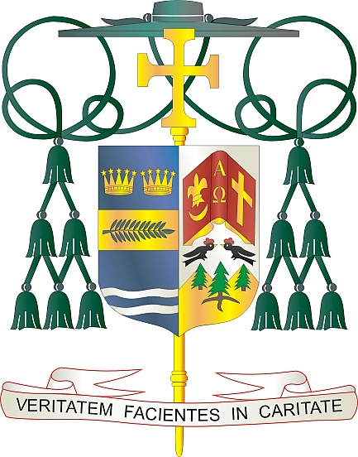
Office of
THE BISHOP

9995 North Military Trail • P.O. Box 109650
Palm Beach Gardens, Florida 33410-9650

(561) 775-9595 Fax (561) 775-7035

Diocese of Palm Beach

July 2024

Dear Brothers and Sisters in Christ,

Natural Family Planning (NFP) Awareness Week is an annual, national educational campaign sponsored by the United States Conference of Catholic Bishops (USCCB) to encourage and support married couples in living a sacramental marriage with Christ-like love, that is, a love that is free, total, faithful, and fruitful. NFP is a modern, scientific method available to couples that addresses their human need for planning their families, while enabling them to participate in God’s creative action without breaking the inseparable link between the unitive and procreative meanings of the conjugal (marital) act. As NFP becomes a way of life, the couple cooperates with each other and God in responsibly planning their family and avoids the devastating spiritual and physical harm caused by artificial contraceptive methods.

This year, NFP Awareness Week is being held from July 21 through July 27 under the theme
of LOVE BEYOND MEASURE: Natural Family Planning… supporting God’s gifts of love and life in marriage. Highlighted during this week is the anniversary of Pope St. Paul VI’s encyclical Humanae Vitae (July 25) which articulates Catholic beliefs about human sexuality, conjugal love, and responsible parenthood. In addition, this week observes the Feast of Saints Joachim and Anne (July 26), the parents of the Blessed Mother and grandparents of Jesus. Pope Francis has designated this feast day as World Grandparents Day, a fitting commemoration during National NFP Awareness Week to celebrate the importance of family and the blessings of children!

As always, but especially during NFP Awareness Week, I would like to congratulate those married couples who live out their marriage commitment to free, total, faithful, and fruitful love. I encourage all married couples and those preparing for marriage to reflect on their current or future marriages and how they can authentically and responsibly fulfill their commitment to fruitful love. If you have not yet considered NFP or have questions, I encourage you to investigate and discover the richness of NFP. Please visit our website at www.diocesepb.org/naturalfamilyplanning for resources and additional information or call 561-775-9557.

With every prayerful wish, I am

Sincerely yours in Christ,

Most Reverend Gerald M. Barbarito
Bishop of Palm Beach

