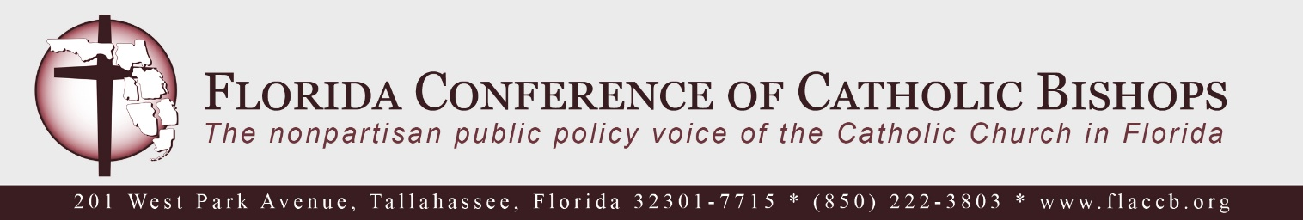

Defeat Florida’s Pro-Abortion Amendment
Checklist for Parishes on Amendment 4

The bishops of Florida urge all parishes in Florida to unite in prayer, distribute materials, and encourage parishioners to vote NO on the proposed amendment to Florida’s Constitution that will appear on the November 5, 2024 ballot as Amendment 4. If passed, the amendment would expand and enshrine abortion in our state constitution at the expense of protections for preborn children and women. To help mobilize these efforts, below is a checklist for parish activities.

Important Dates:
Sept. 26 – Oct. 3, 2024: Mail-in ballots to be sent to domestic voters:
Oct. 26 – Nov. 2, 2024: Early voting period; may begin as early as Oct. 21 in some counties
Nov. 5, 2004: Election Day

Preparation:
Review FCCB parish resources found at: https://www.flaccb.org/abortion-amendment

Collaborate with diocesan Respect Life Office to create your action plan

Identify 2-3 parish leaders that are passionate about respect life initiatives and collaborate well with the pastor and other ministry leaders to help activate this plan

June – November 2024
Suggested Activities:

Distribute FCCB Materials (bishops’ statement, flyers, prayer cards)
- Flyers and/or graphics can be inserted into bulletins
- Prayer can be placed in pews or bulletin and recited before/after Masses

Add link to FCCB campaign page (https://www.flaccb.org/abortion-amendment) to parish website and electronic newsletters

Deliver first pulpit announcement before or after Mass – clergy or lay volunteer (If possible, a woman leader is preferred as studies show that women’s voices are most effective when speaking against abortion.)

Deliver pulpit announcement a second time

Incorporate suggested prayers of the faithful into Masses

Show video or videos provided by FCCB that may include an introduction by local bishop

Set up a table after Masses (and at parish events) staffed by volunteers who can speak about the dangers of the proposed amendment

Coordinate times to pray with and speak to ministry/prayer groups

Encourage Faithful Citizenship and stress the importance of voting (& voting NO) this November

Respect Life Sunday, October 5/6
Suggested Activities:

Concerted push with activities above

Utilize Homily Helps provided on FCCB website to incorporate messaging into homily

Show video provided by FCCB that includes introduction by local bishop

