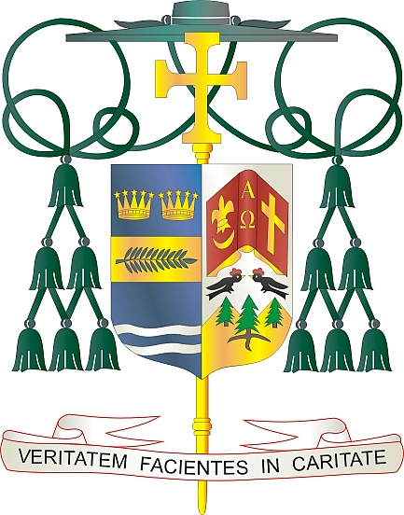
Office of
THE BISHOP

9995 North Military Trail • P.O. Box 109650
Palm Beach Gardens, Florida 33410-9650

(561) 775-9595 Fax (561) 775-7035

Diocese of Palm Beach

February 10, 2024

Dear Sisters and Brothers in Christ:

Next weekend, February 17/18, a collection will be taken up in the parishes of the Diocese of Palm Beach to support our local priests who are living in retirement, many of whom continue to serve the Church in various ministries. Funds received from this special collection help support the priests who have faithfully served our Diocese for decades and remain valued members of the presbyterate.

Your loving support of our retired priests, through your prayers and generous financial assistance, is appreciated. Thank you for your kindness to our retired priests, who graciously give of themselves in service to the people of God.

May God continue to bless you with every grace and strength and may our Blessed Mother always intercede for you.

With gratitude for your continued generosity and every prayerful wish, I am

Sincerely yours in Christ,

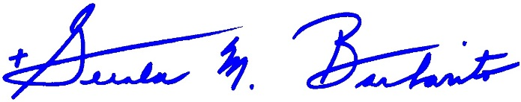
Most Reverend Gerald M. Barbarito
Bishop of Palm Beach

NOTE TO PASTORS: IT IS REQUIRED THAT YOU PUBLISH THIS LETTER IN THE PARISH BULLETIN AS A HALF-PAGE OR FULL-PAGE LETTER THE WEEKEND OF FEBRUARY 10/11, 2024. THE COLLECTION WILL TAKE PLACE FEBRUARY 17/18, 2024. YOU ARE WELCOME TO READ THE LETTER TO PARISHIONERS, POST THIS LETTER ON SOCIAL MEDIA, AND ON YOUR WEBSITE IN ADDITION TO HAVING IT PRINTED IN THE BULLETIN.

