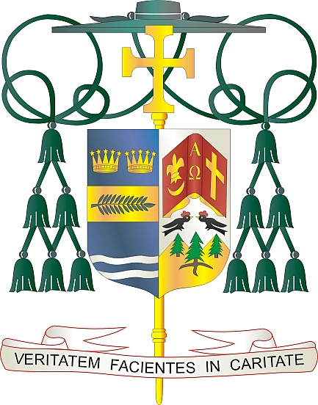
Office of
THE BISHOP

9995 North Military Trail • P.O. Box 109650
Palm Beach Gardens, Florida 33410-9650

(561) 775-9595 Fax (561) 775-7035

Diocese of Palm Beach

March 1, 2024

Dear Sisters and Brothers in Christ:

Next weekend, March 9/10, the Diocese of Palm Beach will take up its annual collection for the education of seminarians and formation of priests, which is an essential need in our Church today. The funds raised in this collection are used to defray the cost of tuition, housing, education and pastoral training of our seminarians.

Currently, there are eight seminarians from our Diocese who are dedicating themselves to this important process of understanding their vocation.

Because of your support, our seminarians can journey in faith without being financially burdened. They can devote themselves fully to the task of priestly formation, thus ensuring that the sacraments will be available to our faithful for many years to come.

St. Paul said, “I am confident of this, that the one who began a good work in you will continue to complete it until the day of Christ Jesus” (Phil 1:6). May the good work forming our seminarians, along with your prayers, pay abundant dividends with an increase in vocations.

With gratitude for your continued generosity and every prayerful wish, I am

Sincerely yours in Christ,
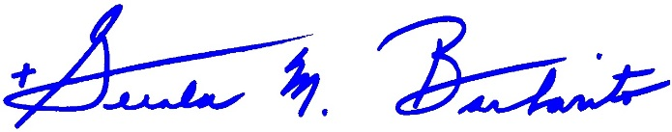
Most Reverend Gerald M. Barbarito
Bishop of Palm Beach

NOTE TO PASTORS: IT IS REQUIRED THAT YOU PUBLISH THIS LETTER IN THE PARISH BULLETIN AS A HALF PAGE OR FULL-PAGE LETTER THE WEEKEND OF MARCH 2/3, 2024. THE COLLECTION WILL TAKE PLACE MARCH 9/10, 2024. YOU ARE WELCOME TO READ THE LETTER TO PARISHIONERS, POST THIS LETTER ON SOCIAL MEDIA, AND ON YOUR WEBSITE IN ADDITION TO HAVING IT PRINTED IN THE BULLETIN.

