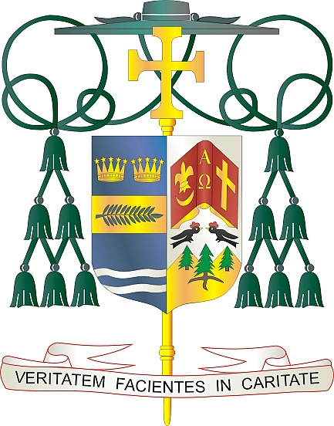
Office of
THE BISHOP

9995 North Military Trail • P.O. Box 109650
Palm Beach Gardens, Florida 33410-9650

(561) 775-9595 Fax (561) 775-7035

Diocese of Palm Beach

June 7, 2021

Dear Sisters and Brothers in the Lord:

I am very pleased to announce that the time has arrived for us in the Diocese of Palm Beach to return to a more normal attendance in church by relaxing the pandemic safety restrictions which have limited us for over a year. As of the weekend of June 19/20, the general dispensation from the obligation to attend Sunday Mass will no longer be necessary and will be lifted. However, one may still excuse oneself from attending Mass for reasons of health, tending to an infirm person, or out of concern for contracting or spreading an illness.

I am also pleased to announce that, as of the same weekend, the majority of safety restrictions in place within our churches will no longer be necessary. It is left to the prudent judgment of each pastor to determine what is best for his particular church. Church chapels may be used for weekday Masses and chapels of Eucharistic adoration may also be opened in accord with liturgical norms. However, for the present time, it will still not be possible to provide Holy Communion under both species as well as to fill traditional holy water fonts. The manner of the sharing of a sign of peace at Mass will be at the prudent discretion of each of the faithful.

Precaution and safety are the primary concerns which must be considered in the matter of wearing masks. In church, it is left to the judgement of each vaccinated person whether to wear a mask or not, while it is a just expectation, in a forum of trust, that an unvaccinated person wear one for the present time. Masks and hand sanitizers will continue to be made available in church.

I am deeply grateful to our priests and all of our faithful who have cooperated so well in following the safety precautions during this difficult time. You have made a Catholic church one of the safest places to be and we want to ensure that this continues for the future. The livestreaming of Masses and liturgical services have proven to be a great blessing and are still encouraged on a local level for the spiritual enrichment of the faithful.

We thank God for the progress that has been made to this point and ask His continued protection in remaining safe and healthy.

With every prayerful wish, I am

Sincerely yours in Christ,
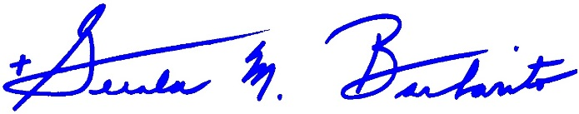
Most Reverend Gerald M. Barbarito
Bishop of Palm Beach

