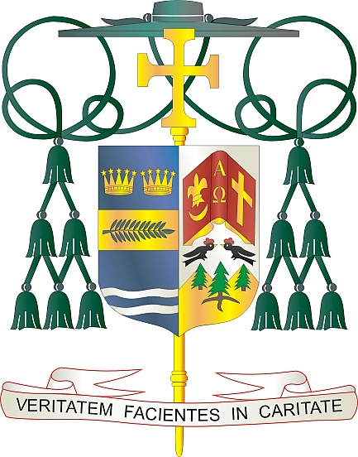

Office of  
THE BISHOP

9995 North Military Trail • P.O. Box 109650

Palm Beach Gardens, Florida 33410-9650

(561) 775-9595 Fax (561) 775-7035

## Diocese of Palm Beach

February 28, 2025

Dear Sisters and Brothers in Christ:

Next weekend, March 8/9, the Diocese of Palm Beach will have its annual second collection for the education of seminarians and formation of priests. The costs associated with these programs are significant and rising all the time.

The funds collected are used to defray the cost of tuition, housing, education and pastoral training of our six seminarians. The yearly cost of tuition for one seminarian is now about $25,000, and the yearly room and board for one seminarian is $15,000. Thanks to your assistance, our seminarians are able to journey in faith without being financially burdened and can devote themselves fully to priestly formation. This year, with God’s help, we will ordain Rev. Mr. Jude Okeke as a priest.

St. Paul said, “I am confident of this, that the one who began a good work in you will continue to complete it until the day of Christ Jesus” (Phil 1:6). May the good work of forming our seminarians, along with your fervent prayers, pay abundant dividends with an increase in vocations for many years to come.

With gratitude for your continued generosity and every prayerful wish, I am

Sincerely yours in Christ,

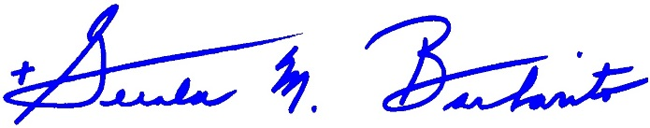

Most Reverend Gerald M. Barbarito  
 Bishop of Palm Beach

**NOTE TO PASTORS:** IT IS REQUIRED THAT YOU PUBLISH THIS LETTER IN THE PARISH BULLETIN AS A HALF-PAGE OR FULL-PAGE LETTER THE WEEKEND OF MARCH 1/2, 2025. THE COLLECTION WILL TAKE PLACE MARCH 8/9, 2025. YOU ARE WELCOME TO READ THE LETTER TO PARISHIONERS, POST THIS LETTER ON SOCIAL MEDIA, AND ON YOUR WEBSITE IN ADDITION TO HAVING IT PRINTED IN THE BULLETIN.