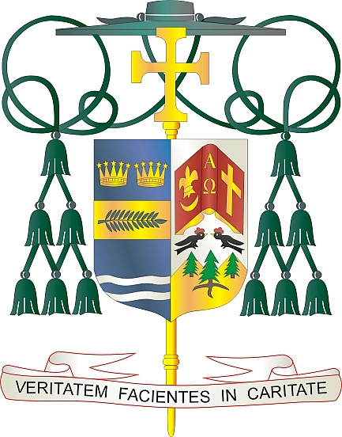
Office of
THE BISHOP

9995 North Military Trail • P.O. Box 109650
Palm Beach Gardens, Florida 33410-9650

(561) 775-9595 Fax (561) 775-7035

Diocese of Palm Beach

June 1, 2024

Dear Sisters and Brothers in Christ:

Next weekend, June 8/9, the Diocese of Palm Beach will collect funds to support two significant initiatives: Black and Indian Missions and the Catholic Home Missions.

The Black and Indian Mission collection, established as the first national collection in 1874, exists to help African American and Native American Catholic communities throughout the United States spread the Good News of Jesus Christ and respond to real and pressing needs on the ground. Your support helps missionaries to serve, form children and adults in the faith and build hope in areas where it is in short supply.

The Catholic Home Missions portion of the collection helps struggling dioceses across our nation and its territories that require financial assistance to sustain their core pastoral services and works of mercy. Your support of this appeal makes a difference in mission communities through programs for evangelization, faith formation, human life and dignity, strengthening marriages and families, and priestly and religious vocations.

With gratitude for your continued generosity and every prayerful wish, I am

Sincerely yours in Christ,
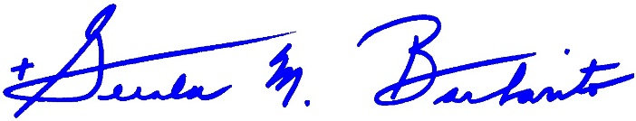
Most Reverend Gerald M. Barbarito
Bishop of Palm Beach

NOTE TO PASTORS: IT IS REQUIRED THAT YOU PUBLISH THIS LETTER IN THE PARISH BULLETIN AS A HALF-PAGE OR FULL-PAGE LETTER THE WEEKEND OF JUNE 1/2, 2024. THE COLLECTION WILL TAKE PLACE JUNE 8/9, 2024. YOU ARE WELCOME TO READ THE LETTER TO PARISHIONERS, POST IT ON SOCIAL MEDIA AND ON YOUR WEBSITE, IN ADDITION TO HAVING IT PRINTED IN THE BULLETIN.

