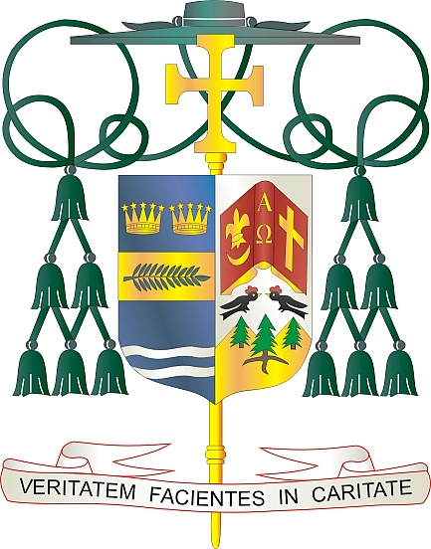

Office of  
THE BISHOP

9995 North Military Trail • P.O. Box 109650

Palm Beach Gardens, Florida 33410-9650

(561) 775-9595 Fax (561) 775-7035

## Diocese of Palm Beach

February 7, 2025

Dear Sisters and Brothers in Christ:

Next weekend, February 15/16, a second collection will be taken up in our parishes to support our local priests living in retirement. Currently, 34 priests who have faithfully served in the Diocese of Palm Beach for decades — many of whom continue to minister in some capacity — are aided by funds donated in this special collection.

Your support of our retired priests, through your prayers and generous financial assistance, is necessary to allow them to continue their work and lead vigorous, purposeful lives in retirement. Please ask God to bless them as you show appreciation for their years of dedicated, life-giving service.

As we celebrate this Jubilee Year, which is a time of hope for the world, in addition to a time to re-establish relationships with God, others, and creation, let us reflect on the hope we have as a diocese. Your support of this collection and the prayers you provide to our priests, are a special sign of hope in our parishes and community.

With gratitude for your continued generosity and every prayerful wish, I am

Sincerely yours in Christ,

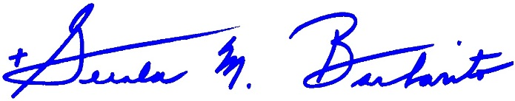

Most Reverend Gerald M. Barbarito  
 Bishop of Palm Beach

**NOTE TO PASTORS: IT IS REQUIRED THAT YOU PUBLISH THIS LETTER IN THE PARISH BULLETIN AS A HALF-PAGE OR FULL-PAGE LETTER THE WEEKEND OF FEBRUARY 8/9, 2025. THE COLLECTION WILL TAKE PLACE FEBRUARY 15/16, 2025. YOU ARE WELCOME TO READ THE LETTER TO PARISHIONERS, POST THIS LETTER ON SOCIAL MEDIA, AND ON YOUR WEBSITE IN ADDITION TO HAVING IT PRINTED IN THE BULLETIN.**