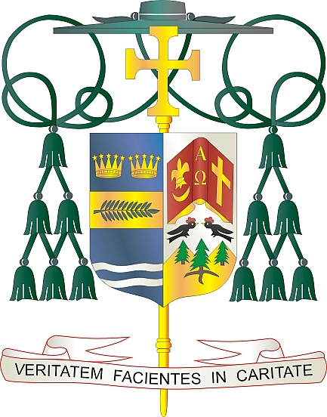

Office of  
THE BISHOP

9995 North Military Trail • P.O. Box 109650

Palm Beach Gardens, Florida 33410-9650

(561) 775-9595 Fax (561) 775-7035

## Diocese of Palm Beach

March 22, 2024

Dear Sisters and Brothers in Christ:

Pope Francis has asked parishes to support the annual Pontifical Good Friday Collection, to be held on March 29, 2024. The Franciscans of the Custody of the Holy Land have the unique responsibility to care for the Holy Places as well for the “living stones,” the Christians living there. The collection supports the work of the Franciscans who maintain and safeguard sacred sites and shrines, minister in parishes, provide formation and education in schools, and care for the temporal needs of all people.

It is vital that we support Christians living in and visiting the Holy Land to maintain a Christian presence in the very land made holy by the life, death and Resurrection of Jesus. Part of the collection goes toward educational and ecclesial projects in the Middle East, while the remainder supports the ministries and programs entrusted by the Holy See to the Franciscans of the Holy Land.

Thank you for supporting the Pontifical Good Friday Collection, as encouraged by Pope Francis. By supporting these efforts, you stand with the Church in the Holy Land and you become an instrument of peace in a troubled land.

With gratitude for your continued generosity and every prayerful wish, I am

Sincerely yours in Christ,

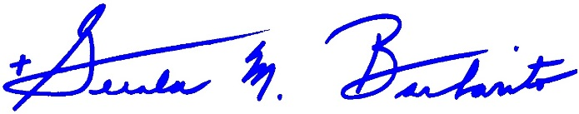 Most Reverend Gerald M. Barbarito  
 Bishop of Palm Beach

**NOTE TO PASTORS: IT IS REQUIRED THAT YOU PUBLISH THIS LETTER IN THE PARISH BULLETIN AS A HALF-PAGE OR FULL-PAGE LETTER THE WEEKEND OF MARCH 23/24, 2024. THE COLLECTION WILL TAKE PLACE MARCH 29, 2024. YOU ARE WELCOME TO READ THE LETTER TO PARISHIONERS, POST THIS LETTER ON SOCIAL MEDIA, AND ON YOUR WEBSITE, IN ADDITION TO HAVING IT PRINTED IN THE BULLETIN.**