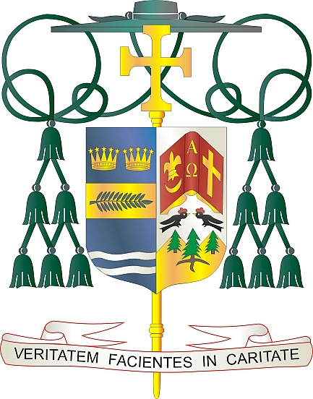

Office of  
THE BISHOP

9995 North Military Trail • P.O. Box 109650

Palm Beach Gardens, Florida 33410-9650

(561) 775-9595 Fax (561) 775-7035

## Diocese of Palm Beach

January 3, 2025

Dear Sisters and Brothers in Christ:

Next weekend, January 11/12, the parishes of the Diocese of Palm Beach will take up a second collection to support local Catholic schools. Our Diocese’s 20 schools include three high schools, three preschools, two private schools and 12 elementary schools, with more than 7,200 students being educated by 600 educational and support staff.

This year’s diocesan theme for Catholic education is *“Live the Light of Christ,”* which conveys our duty to pass on the message of Jesus Christ, the Light of the World, to successive generations. Just as the mission of our Catholic schools is to build learning communities based on the Gospel message and rich in Catholic values and tradition, we also are to *Live the Light of Christ* and reflect His faith, hope and love in the world.

I invite all parishioners to give the gift of faith to a student wishing to attend a Catholic school in our Diocese. Financial support provides funding for programs and resources that may otherwise be out of reach. Thank you very much for your prayers and gifts to assist the students and families in our Catholic schools.

With gratitude for your continued generosity and every prayerful wish, I am

Sincerely yours in Christ,

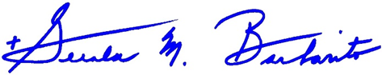

Most Reverend Gerald M. Barbarito  
 Bishop of Palm Beach

**NOTE TO PASTORS: IT IS REQUIRED THAT YOU PUBLISH THIS LETTER IN THE PARISH BULLETIN AS A HALF-PAGE OR FULL-PAGE LETTER THE WEEKEND OF JANUARY 4/5, 2025. THE COLLECTION WILL TAKE PLACE JANUARY 11/12, 2025. YOU ARE WELCOME TO READ THE LETTER TO PARISHIONERS, POST THE LETTER ON SOCIAL MEDIA, AND ON YOUR WEBSITE, IN ADDITION TO HAVING IT PRINTED IN THE BULLETIN.**