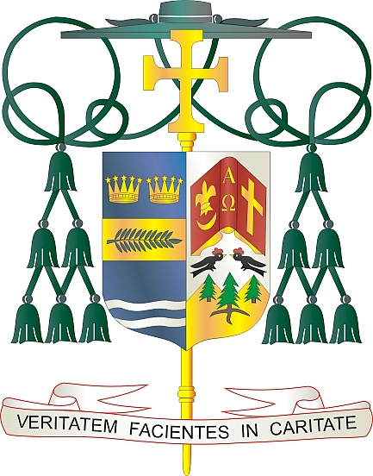

Office of  
THE BISHOP

9995 North Military Trail • P.O. Box 109650

Palm Beach Gardens, Florida 33410-9650

(561) 775-9595 Fax (561) 775-7035

## Diocese of Palm Beach

April 12, 2024

Dear Brothers and Sisters in Christ:

Next weekend, April 20 and 21, the Diocese of Palm Beach will conduct the annual Peter’s Pence Collection, which directs funds to charitable projects supported by Pope Francis, along with activities carried out by the Holy See, such as formation of clergy, communications, promotion of human development, education and justice.

Contributing to this collection is a way to collaborate with the Holy Father as he builds up works of evangelization (spiritual, educational, justice, communication, political charity, diplomatic activity, etc.) and meets the material needs of struggling dioceses, organizations and individuals experiencing all kinds of hardship. Your donations aid the worldwide mission of the Church and the Pope’s role as the Successor of St. Peter.

By supporting Peter’s Pence, the faithful share in the work of Pope Francis through the activities of the Holy See, humanitarian initiatives and social promotion projects in favor of the world’s most needy. Your attention to this collection would be much appreciated.

With gratitude for your continued generosity and every prayerful wish, I am

Sincerely yours in Christ,

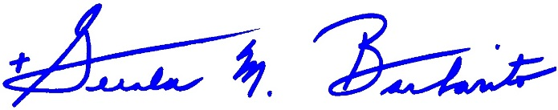

Most Reverend Gerald M. Barbarito  
 Bishop of Palm Beach

**NOTE TO PASTORS: IT IS REQUIRED THAT YOU PUBLISH THIS LETTER IN THE PARISH BULLETIN AS A HALF PAGE OR FULL-PAGE LETTER THE WEEKEND OF APRIL 13/14, 2024. THE COLLECTION WILL TAKE PLACE APRIL 20/21, 2024. YOU ARE WELCOME TO READ THE LETTER TO PARISHIONERS, POST THIS LETTER ON SOCIAL MEDIA, AND ON YOUR WEBSITE IN ADDITION TO HAVING IT PRINTED IN THE BULLETIN.**