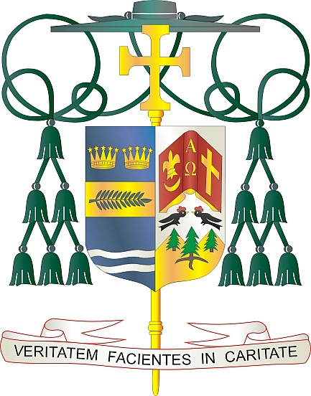

Office of  
THE BISHOP

9995 North Military Trail • P.O. Box 109650

Palm Beach Gardens, Florida 33410-9650

(561) 775-9595 Fax (561) 775-7035

## Diocese of Palm Beach

April 18, 2025

Dear Brothers and Sisters in Christ:

Throughout centuries of history, Catholics have supported the Church’s mission of evangelization and charity by giving to the Peter’s Pence Collection. This project, which began as a way for Catholics around the world to express their unity with the Pope, continues to the present day. Next weekend, April 26/27, the Diocese of Palm Beach urges your participation in this annual collection, which directs funds to charitable work supported by Pope Francis, along with activities carried out by the Holy See, such as formation of clergy, communications, promotion of human development, education and justice.

Contributing to this collection is a way to collaborate with the Holy Father as he builds up works of evangelization (spiritual, educational, justice, communication, diplomatic activity, etc.) and meets the material needs of struggling dioceses, organizations and individuals. Your donations aid the worldwide mission of the Church and the Pope’s role as the Successor of St. Peter.

By supporting Peter’s Pence, the faithful share in the Pope’s work through the Holy See’s activities, humanitarian initiatives and social promotion projects in favor of the world’s most needy. Your attention to this collection would be much appreciated.

With gratitude for your continued generosity and every prayerful wish, I am

Sincerely yours in Christ,

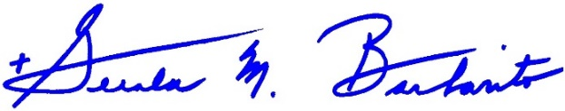

Most Reverend Gerald M. Barbarito  
 Bishop of Palm Beach

**NOTE TO PASTORS: IT IS REQUIRED THAT YOU PUBLISH THIS LETTER IN THE PARISH BULLETIN AS A HALF PAGE OR FULL-PAGE LETTER THE WEEKEND OF APRIL 19/20, 2025. THE COLLECTION WILL TAKE PLACE APRIL 26/27, 2025. YOU ARE WELCOME TO READ THE LETTER TO PARISHIONERS, POST THIS LETTER ON SOCIAL MEDIA, AND ON YOUR WEBSITE IN ADDITION TO HAVING IT PRINTED IN THE BULLETIN.**