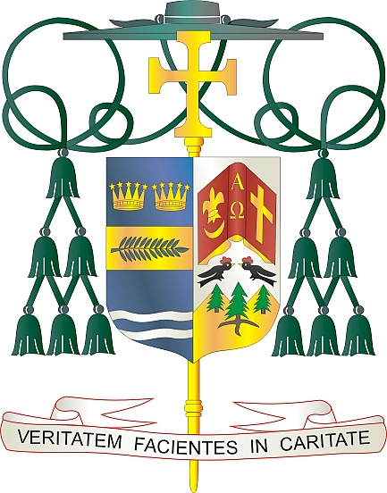
Office of
THE BISHOP

9995 North Military Trail • P.O. Box 109650
Palm Beach Gardens, Florida 33410-9650

(561) 775-9595 Fax (561) 775-7035

Diocese of Palm Beach

August 2, 2024

Dear Brothers and Sisters in Christ:

Next weekend, August 10/11, our Diocese will collect funds to support the Church in Latin America/Caribbean and the Solidarity Fund for the Church in Africa. The proceeds will be split between these two initiatives to better serve those most in need.
The Diocese of Palm Beach is blessed by the presence of many faithful from Latin America and the Caribbean in numerous parishes. For more than 50 years, we have aided ministries, seminaries and formation programs throughout Central America and the Caribbean, and we are served by numerous priests from the area.
The Solidarity Fund for the Church in Africa helps to renew faith, strengthen families, and support formation programs for clergy and religious. Giving to the Solidarity Fund supports the rapidly growing Church in Africa to joyfully live the merciful love of Jesus through its ministries to families, youth, and those living on the periphery of society.

Your generosity, as well as your prayers, makes a difference in countless lives.

With gratitude for your continued generosity and with every prayerful wish, I am

Sincerely yours in Christ,
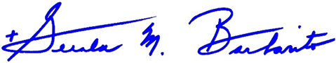

Most Reverend Gerald M. Barbarito
Bishop of Palm Beach

NOTE TO PASTORS: IT IS REQUIRED THAT YOU PUBLISH THIS LETTER IN THE PARISH BULLETIN AS A HALF-PAGE OR FULL-PAGE LETTER THE WEEKEND OF AUGUST 3/4. THE COLLECTION WILL TAKE PLACE AUGUST 10/11, 2024. YOU ARE WELCOME TO READ THE LETTER TO PARISHIONERS, POST THIS LETTER ON SOCIAL MEDIA, AND ON YOUR WEBSITE IN ADDITION TO HAVING IT PRINTED IN THE BULLETIN.

