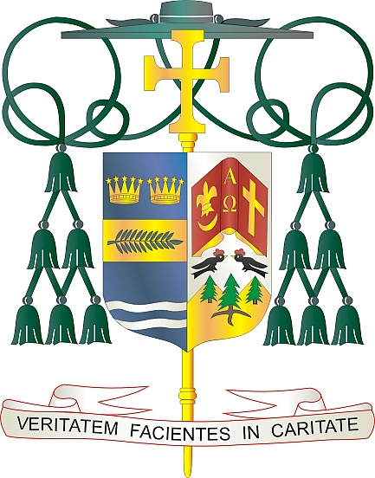
Office of
THE BISHOP

9995 North Military Trail • P.O. Box 109650
Palm Beach Gardens, Florida 33410-9650

(561) 775-9595 Fax (561) 775-7035

Diocese of Palm Beach

July 5, 2024

Dear Sisters and Brothers in Christ:

Our parishes will take up a collection next weekend, July 13/14, to support Catholic Relief Services (CRS), which provides emergency assistance to victims of war and natural disasters; assists migrants and refugees who need housing, education and specialized legal assistance; and supports travelers and others whose livelihoods require special pastoral support to access the sacraments. In addition to aiding those with immediate needs, your assistance helps long-term efforts to build peace in regions that have been affected by decades of conflict.

Your generosity assists countless souls, domestically and internationally, and in a real way you become a lifeline to a better future for them and their families. Whether from natural disasters or human conflict, CRS responds to the needs of those trying to rebuild their lives.

Please prayerfully consider how you can support this 2024 collection. To learn more about the collection and the people who benefit, please visit www.usccb.org/catholic-relief. Thank you again for all that you do, prayerfully and financially, to help those burdened by poverty, famine, war and natural catastrophes.

With gratitude for your continued generosity and every prayerful wish, I am

Sincerely yours in Christ,
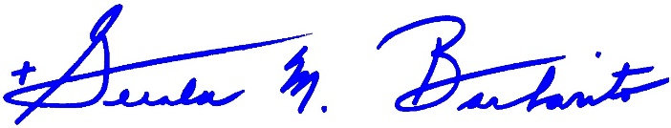

Most Reverend Gerald M. Barbarito
Bishop of Palm Beach

NOTE TO PASTORS: IT IS REQUIRED THAT YOU PUBLISH THIS LETTER IN THE PARISH BULLETIN AS A HALF-PAGE OR FULL-PAGE LETTER THE WEEKEND OF JULY 6/7, 2024. THE COLLECTION WILL TAKE PLACE JULY 13/14, 2024. YOU ARE WELCOME TO READ THE LETTER TO PARISHIONERS, POST THE LETTER ON SOCIAL MEDIA, AND ON YOUR WEBSITE, IN ADDITION TO HAVING IT PRINTED IN THE BULLETIN.

