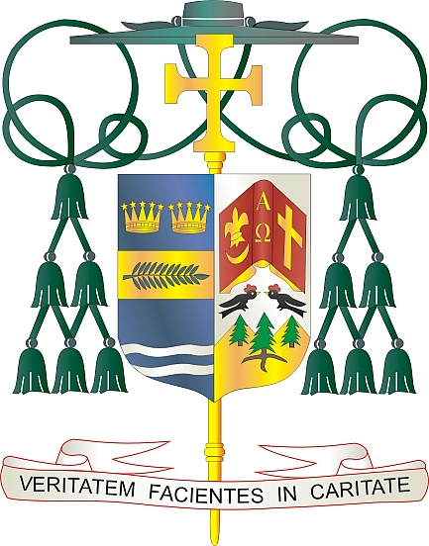

Office of  
THE BISHOP

9995 North Military Trail • P.O. Box 109650

Palm Beach Gardens, Florida 33410-9650

(561) 775-9595 Fax (561) 775-7035

## Diocese of Palm Beach

April 11, 2025

Dear Sisters and Brothers in Christ:

Every year, our Holy Father asks parishioners to contribute to the Pontifical Good Friday collection, which seeks to bolster the Christian presence in the Holy Land, support ministry in its sacred shrines and parishes, provide for formation and education in communities and schools, and fund basic needs for all people. The 2025 collection will be taken up on Good Friday, April 18.

Your awareness of and charitable generosity for this year’s collection will help enable Christians and the Catholic Church to stay in the Holy Land, in the very land made holy by the life, death and Resurrection of Jesus. The Franciscans of the Custody of the Holy Land help maintain and safeguard sacred sites and shrines, as well as care for the “living stones” who are present among them.

We humbly ask for your prayers and financial support for this annual collection, as encouraged by Pope Francis. By supporting these efforts, you stand with the Church in the Holy Land, and you become an instrument of peace in a troubled region.

With gratitude for your continued generosity and every prayerful wish, I am

Sincerely yours in Christ,

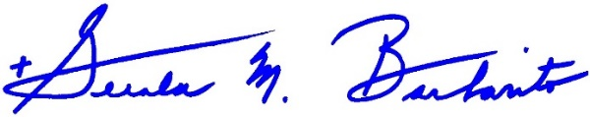

Most Reverend Gerald M. Barbarito  
 Bishop of Palm Beach

**NOTE TO PASTORS: IT IS REQUIRED THAT YOU PUBLISH THIS LETTER IN THE PARISH BULLETIN AS A HALF-PAGE OR FULL-PAGE LETTER THE WEEKEND OF APRIL 12/13, 2025. THE COLLECTION WILL TAKE PLACE APRIL 18, 2025. YOU ARE WELCOME TO READ THE LETTER TO PARISHIONERS, POST THIS LETTER ON SOCIAL MEDIA, AND ON YOUR WEBSITE, IN ADDITION TO HAVING IT PRINTED IN THE BULLETIN.**