

Office of  
THE BISHOP

9995 North Military Trail • P.O. Box 109650

Palm Beach Gardens, Florida 33410-9650

(561) 775-9595 Fax (561) 775-7035

## Diocese of Palm Beach

October 4, 2024

Dear Sisters and Brothers in Christ:

Next weekend, October 12/13, the parishes in our diocese will participate in a second collection for World Mission Sunday, observed October 20. The 2024 World Mission Sunday theme, chosen by Pope Francis, is “Go and Invite Everyone to the Banquet” (Matt 22:9), which reflects on the Gospel parable of the wedding banquet. In the parable, the king tells his servants, “Go therefore to the thoroughfares and invite to the marriage feast as many as you find.” This invitation to the king’s feast is beautifully expressed by Christ’s invitation to believe and participate in the Banquet of His Body and Blood offered for us.

This annual collection supports more than 1,000 Catholic communities in Asia, Africa, the Pacific Islands, and parts of Latin America and Europe. By supporting this effort, we join with the faithful throughout the world to assist these missions and ministries and provide help for those most in need of God’s mercy.

As our Holy Father wrote regarding World Mission Sunday, “Here it should be remembered that breaking our material bread with the hungry in the name of Christ is already a work of Christian mission. How much more so is the breaking of the Eucharistic bread, which is Christ himself, a work of mission par excellence, since the Eucharist is the source and summit of the life and mission of the Church.”

With gratitude for your continued generosity and every prayerful wish, I am

Sincerely yours in Christ,

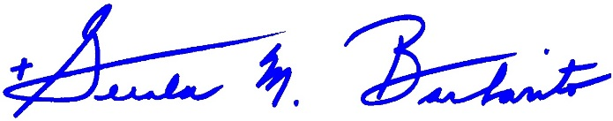

Most Reverend Gerald M. Barbarito  
 Bishop of Palm Beach

**NOTE: IT IS REQUIRED THAT YOU PUBLISH THIS LETTER IN THE PARISH BULLETIN AS A HALF PAGE OR FULL-PAGE LETTER THE WEEKEND OF OCTOBER 5/6, 2024. THE COLLECTION WILL TAKE PLACE OCTOBER 12/13, 2024. YOU ARE WELCOME TO READ THE LETTER TO PARISHIONERS, POST THIS LETTER ON SOCIAL MEDIA, AND ON YOUR WEBSITE IN ADDITION TO HAVING IT PRINTED IN THE BULLETIN.**